CSI5388/ELG5271 – Assignment 2
DNS Data Exfiltration Detection: Static and Dynamic ML Models

Introduction
This report presents a complete ML pipeline to detect DNS data exfiltration via binary classification. Two datasets were used: static_dataset.csv (268,074 records) for Part I, and kafka_dataset.csv (268,064 records) streamed through Apache Kafka for Part II. The pipeline covers data analysis, feature engineering, model training, and a comparison between a frozen static model and an adaptive dynamic model.

Part I – Static Model

1.1 Data Analysis
Class balance: 147,179 attacks (54.9%) vs 120,895 benign (45.1%); imbalance ratio = 1.22. Mild imbalance so no oversampling needed, but F1 and AUC-ROC are used instead of accuracy.
Feature distributions: Several features are right-skewed (upper: skew=5.99, labels_average: 5.09). Shannon entropy is the most discriminative feature: exfiltration encodes data in high-entropy subdomains (base64 payloads), clearly separating attack from benign traffic in boxplots.
Correlations: special and labels are near-perfectly correlated (r=0.99); numeric correlates strongly with both (0.94). Features most correlated with target: numeric (0.60), FQDN_count (0.56), subdomain_length (0.57).
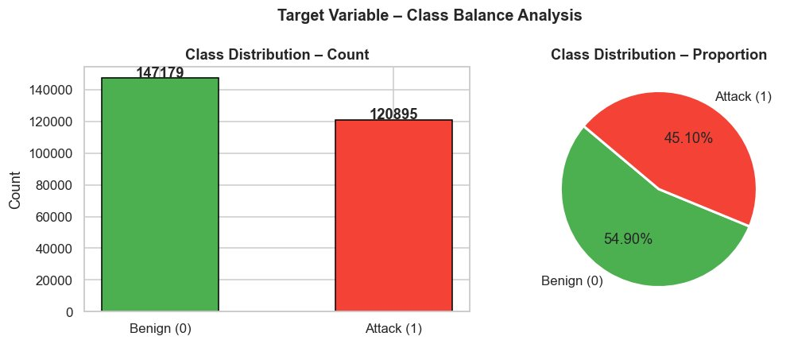  Fig. 1: Class distribution (ratio=1.22) | 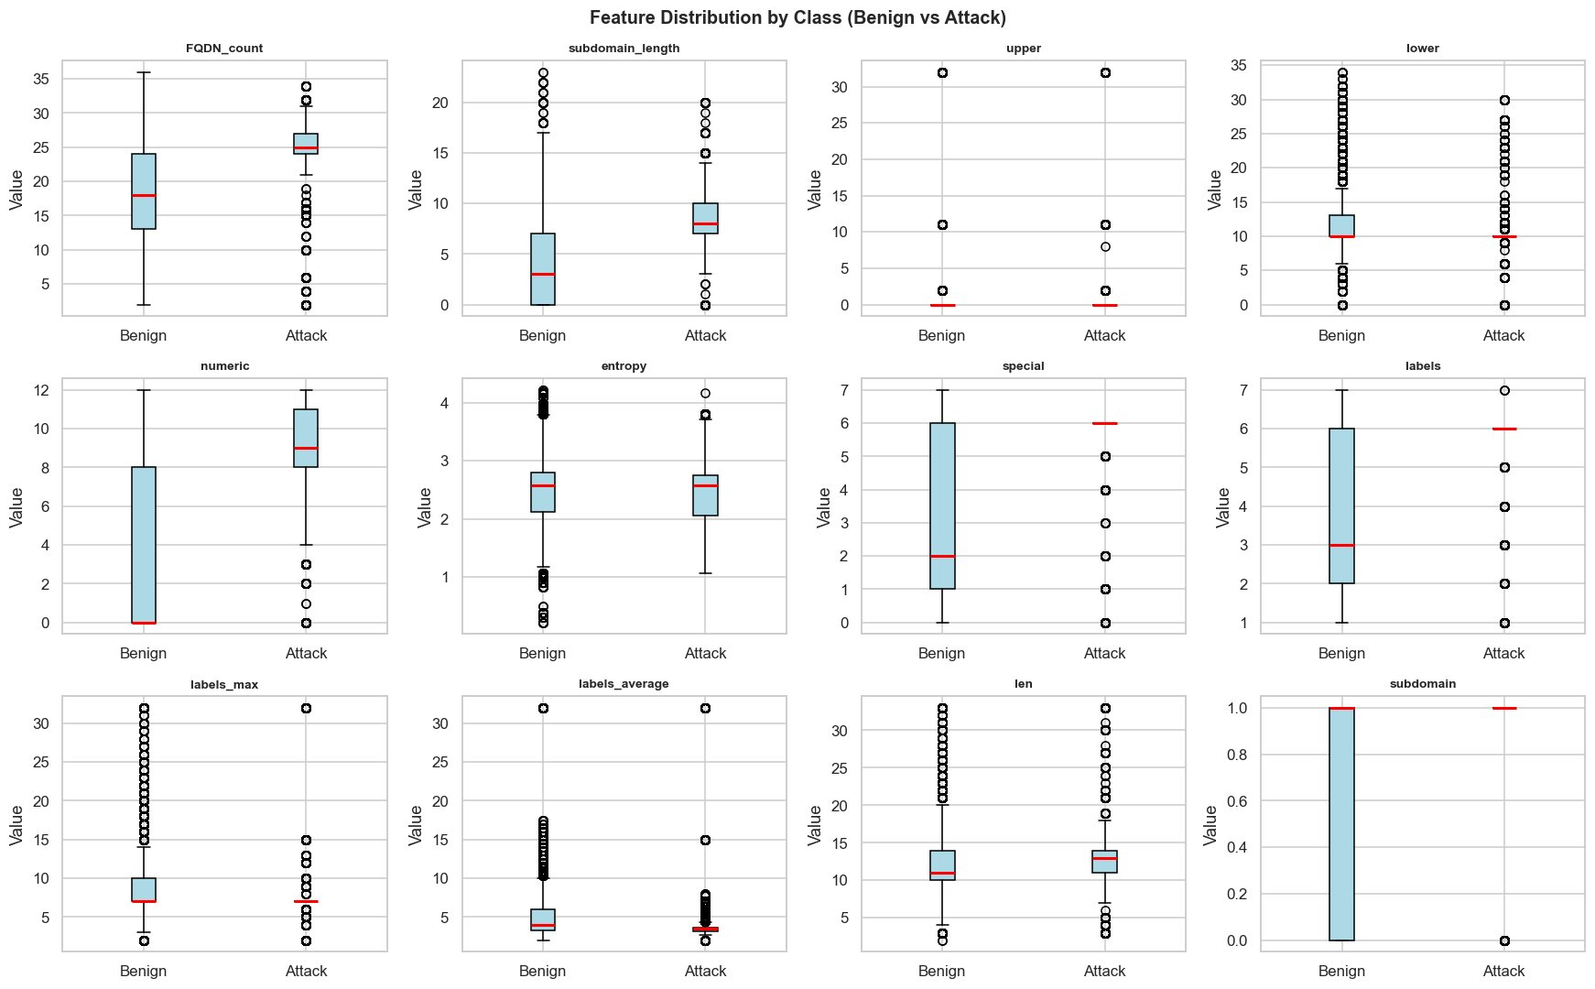  Fig. 2: Feature boxplots by class

1.2 Feature Engineering and Data Cleaning
String encoding: timestamp parsed to seconds; sld (11,112 unique) and longest_word (6,224 unique) encoded via MD5 hashing trick (65,536 buckets) – avoids high-cardinality one-hot encoding.
Missing values: Only 8 rows missing in longest_word; imputed with column median. All 15 features numeric after preprocessing.

1.3 Feature Selection (Three Methods)
(1) Mutual Information: Non-linear dependency measure. Top: longest_word_hash, sld_hash, labels, special.
(2) ANOVA F-Test: Linear class-mean separation. All features p<0.001. Top F-scores: numeric, special, subdomain_length.
(3) RF Gini Importance: Interaction effects captured. Top: subdomain_length, FQDN_count, special, labels.
Ranks from all three methods were averaged. 12 features with avg rank ≤ 10 selected: special, labels, FQDN_count, numeric, subdomain_length, longest_word_hash, lower, sld_hash, subdomain, labels_average, entropy, labels_max. Dropped: timestamp_sec, upper, len (low across all methods).
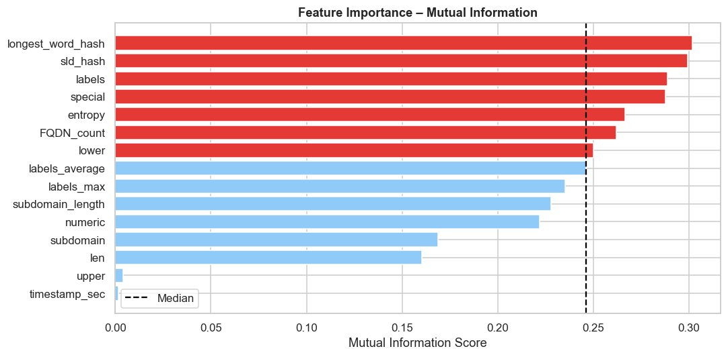  Fig. 3: Mutual Information scores | 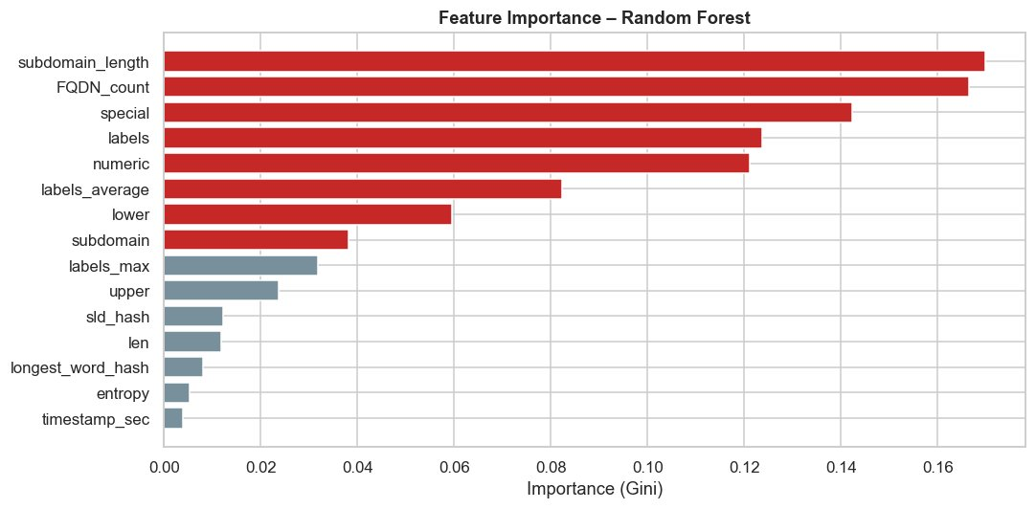  Fig. 4: RF Gini importance

1.4 Model Training and Hyperparameter Tuning
Split: Stratified 80/20 (214,459 train / 53,615 test). Stratification preserves class ratio. StandardScaler fitted on train only to prevent leakage.
Metrics: F1-Score is primary – missed attacks are more costly than false alarms. Supplemented by ROC-AUC and PR-AUC. Accuracy avoided: a naive all-attack classifier achieves 54.9%.
(1) Random Forest: 200 trees, max_depth=20, class_weight="balanced". Robust, fast inference handles interactions.
(2) Gradient Boosting: 200 estimators, lr=0.1, max_depth=5, subsample=0.8. Sequential error-correction, generally higher accuracy on tabular data. Both tuned via 3-fold StratifiedKFold GridSearchCV optimizing F1.
Metric | Random Forest | Gradient Boosting
F1-Score (Attack) | 0.8631 | 0.8631
Precision | 0.757 | 0.757
Recall | 1.000 | 1.000
ROC-AUC | 0.8051 | 0.8024
PR-AUC | 0.7581 | 0.7531
Table 1: Test set metrics (53,615 samples). RF selected as final model.

1.5 Model Evaluation and Discussion
Both models achieve identical F1 (0.8631) with perfect attack recall (1.00) but only 75.7% precision – every attack caught; some benign queries flagged as attacks. Acceptable in security contexts. Random Forest selected for better ROC-AUC (0.8051 vs 0.8024) and PR-AUC (0.7581 vs 0.7531). Model, scaler, and features saved to disk for Part II.
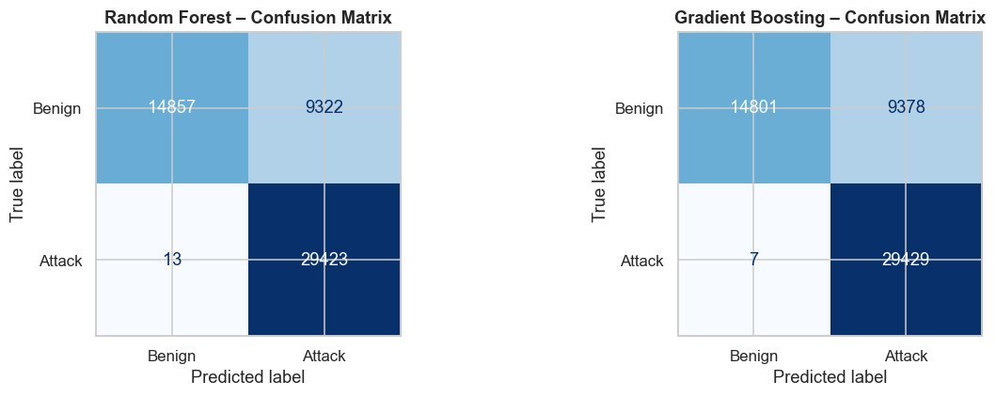  Fig. 5: Confusion matrices – perfect attack recall | 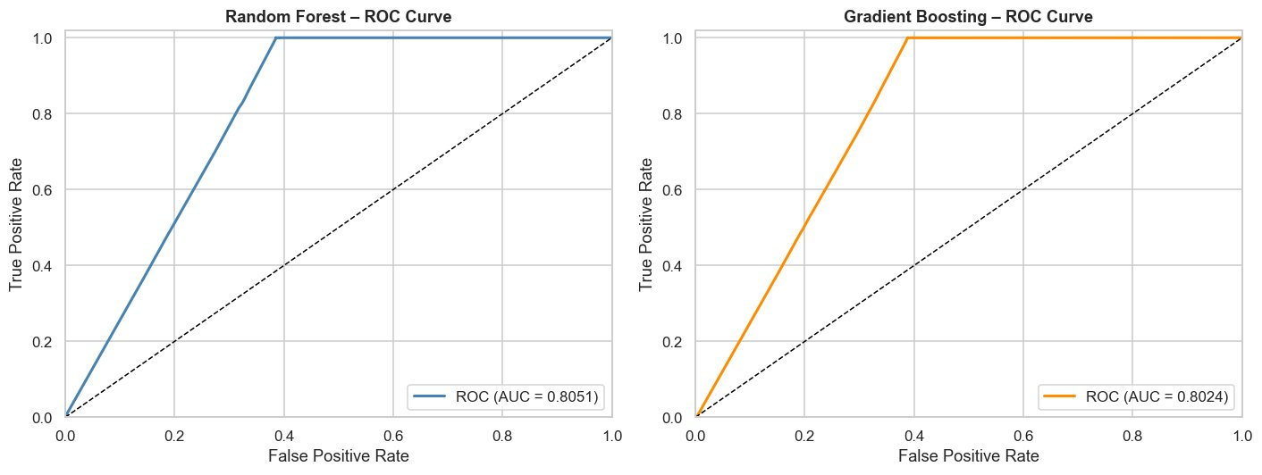  Fig. 6: ROC curves (RF AUC=0.8051)

Part II – Dynamic Model (Online Learning)

2.1 Setup and Architecture
The Kafka dataset (268,064 rows) is ingested by a producer in Docker and consumed window-by-window. Two models run in parallel: (1) Static model – RF from Part I, never updated. (2) Dynamic model – deep copy of static, conditionally retrained when performance drops. Both apply identical per-window preprocessing.

2.2 Window Processing and Metrics
Stream divided into 1,000-observation windows (268 total). After each window, both models are evaluated. F1-Score is the primary tracking metric because drops directly mean more missed attacks or more false alarms. ROC-AUC and PR-AUC are also recorded.

2.3 Retraining Decision Boundary
Rule: retrain the dynamic model if current F1 drops more than 2% below the tracked baseline. Baseline initialized from Window 1, then updated via EMA (alpha=0.1): baseline = 0.9 × baseline + 0.1 × F1. The EMA smooths single-window noise. The 2% threshold equals ~20 extra misclassifications per window – a meaningful operational degradation.

2.4 Results Analysis
Dynamic model retrained 7 times (windows 32, 87, 113, 153, 161, 206, 265) – 2.6% of all windows. Both models remained stable throughout.
Metric | Static Model | Dynamic Model
Avg F1-Score | 0.8558 +/- 0.0102 | 0.8523 +/- 0.0104
Avg ROC-AUC | 0.7951 | 0.7947
Avg PR-AUC | 0.7453 | 0.7433
Retrain events | none | 7 / 268
Min / Max F1 | 0.822 / 0.877 | 0.823 / 0.877
Table 2: Streaming performance across 268 windows
The static model's average F1 (0.8558) is marginally higher than the dynamic model (0.8523) because retraining on 1,000 samples causes slight underfitting vs. a model trained on 200K+. On a dataset without strong concept drift, the static model holds up. However, the performance gap plot shows the dynamic model outperforms right after retraining events, confirming it adapts to local distribution shifts. In a real deployment with evolving attack techniques, the dynamic model would be clearly superior.
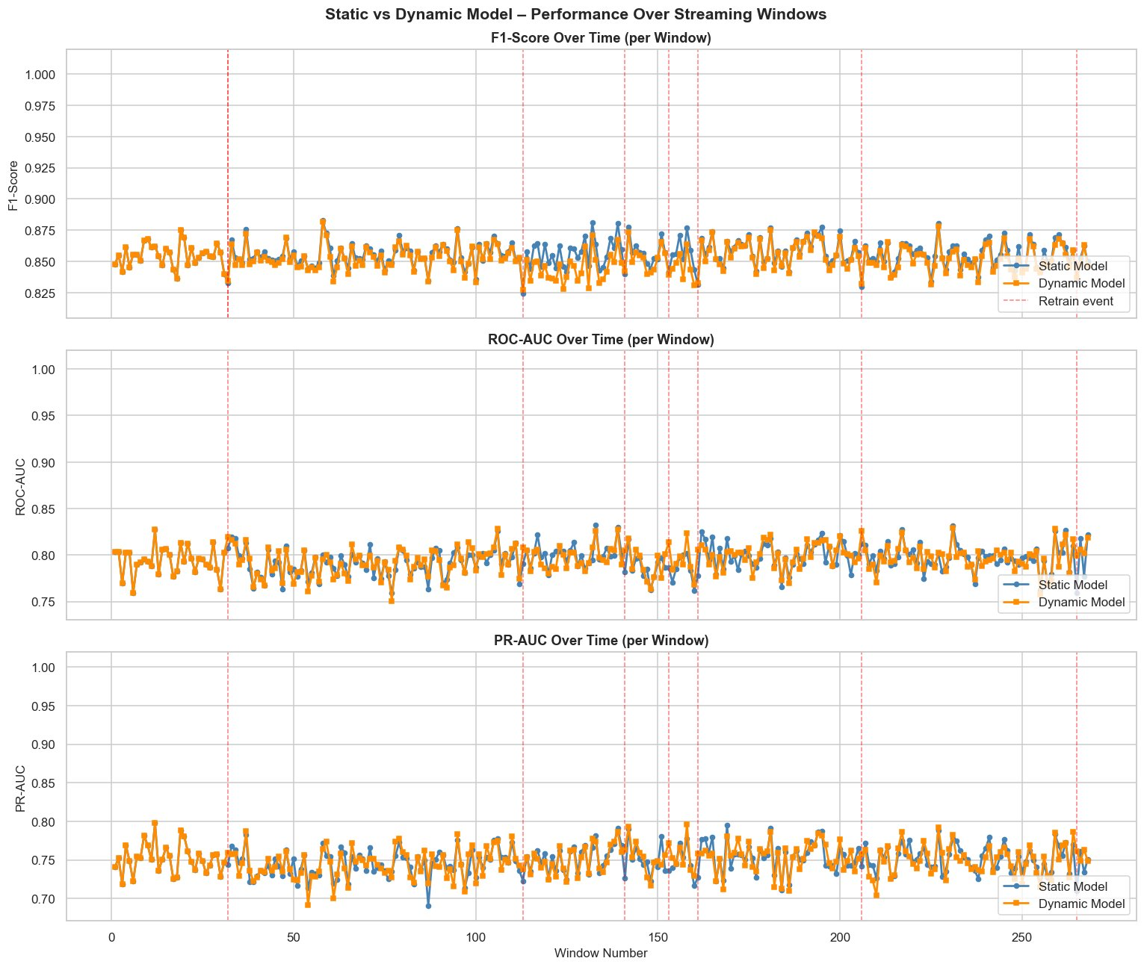
Fig. 7: F1, ROC-AUC and PR-AUC per window for both models. Red dashed lines = 7 retraining events.
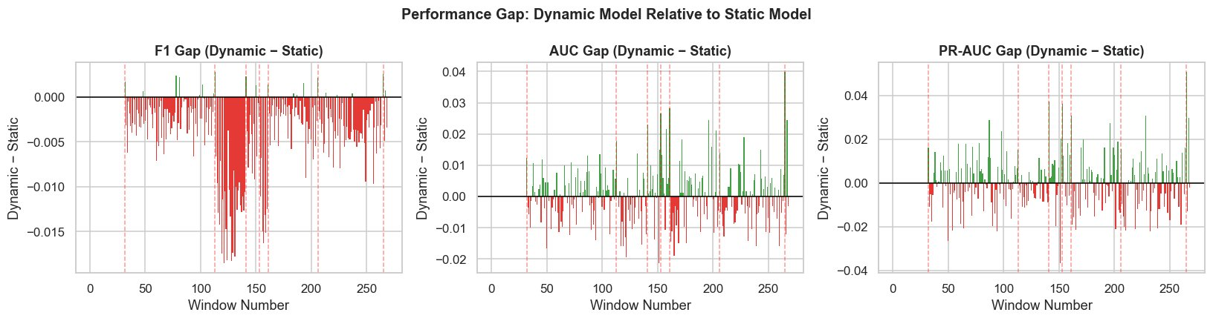  Fig. 8: Performance gap (Dynamic minus Static) | 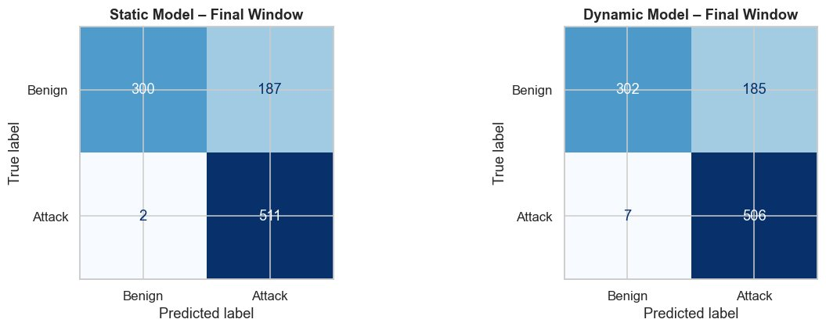  Fig. 9: Final window confusion matrices

2.5 Advantages, Limitations and Lessons Learned
Advantages: (1) Drift adaptation – dynamic model self-corrects as attack patterns evolve, while the static model silently degrades. (2) Low overhead – 7 retrains × <5s each is negligible. (3) Conservative updates via EMA prevent noise-triggered retraining.
Limitations: (1) Catastrophic forgetting – retraining on 1,000 samples discards historical patterns; a sliding buffer would help. (2) Small window underfitting – ensemble methods need more data. (3) Heuristic threshold – the 2% rule needs tuning per deployment; ADWIN/DDM detectors would be more principled. (4) Operational complexity – online pipelines need Kafka monitoring and consumer health checks.

Conclusion
Part I produced a Random Forest classifier (F1=0.8631, AUC=0.8051) trained on 268K DNS records, achieving perfect attack recall (100%) after MD5-based feature engineering and consensus feature selection across three statistical methods.
Part II compared the frozen static model against an adaptive copy over 268 Kafka stream windows. The dynamic model retrained 7 times using an EMA-adjusted F1 threshold. On this dataset, both models performed comparably (avg F1: 0.8558 vs 0.8523) due to limited concept drift. However, the dynamic approach is the better long-term choice for real deployments where attack methods evolve – the static model would degrade monotonically while the dynamic model self-corrects automatically with minimal computational overhead.

